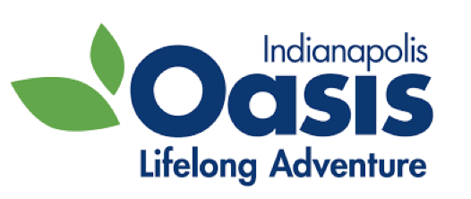
Indianapolis Oasis Reopening and Sanitation Policy
In keeping with the CDC, health system and governing authorities we welcome Oasis members to return to limited in-person class offerings. Guidelines may change as new recommendations from the CDC are released.
The following guidelines will be followed in all Indianapolis Oasis locations:
- Oasis will be practicing social distancing.

- Class sizes for all classrooms will be limited-Washington Park 12 fitness/16 LLL, Broad Ripple 12 fitness/16 LLL, Healthplex 12 fitness/20 LLL and Greenwood 12 fitness

- Mats and/or equipment may be utilized in fitness classes. Must take home.

- Masks will be required for all participants, volunteers and staff at all times with the exception of staff while they are in their private offices.

- Each day Oasis will complete sanitizing processes in common areas, bathrooms and classrooms – Indianapolis Healthplex and First Baptist Church Greenwood locations may differ -Oasis will follow guidelines set by these identities.

- Gloves will be used by staff during sanitizing.

- Oasis will check participants in for each class.

- Oasis will not provide paper handouts or require evaluations for classes.

- Classroom floors will be marked for chair placement for exercise and lifelong learning classes. Indianapolis Healthplex and First Baptist Church Greenwood locations may differ – Oasis will follow guidelines set by these identities.

- Hand and spray sanitizer will be placed on tables outside of classrooms for participants.

- Hand washing signs will be posted in all Oasis locations.

